Title:RecipeWiki

Who: Daniel Rafael,Haotian Dong, Hua-Pei Yen, Jacky Cheung, Joel Davidson

Project Tracker: Trello, iPhone group message

VCS: Github/BuffTech

Deployment: After pulling/copying in the database from github, with its structure and tables, run the mysql scripts from the .sql files. Change the mySQL password for all the queries in each php file to your mysql password. Then put the respective php and html files in the /var/www/html/ directory and run it using localhost on your web server.

Contributions:

Daniel

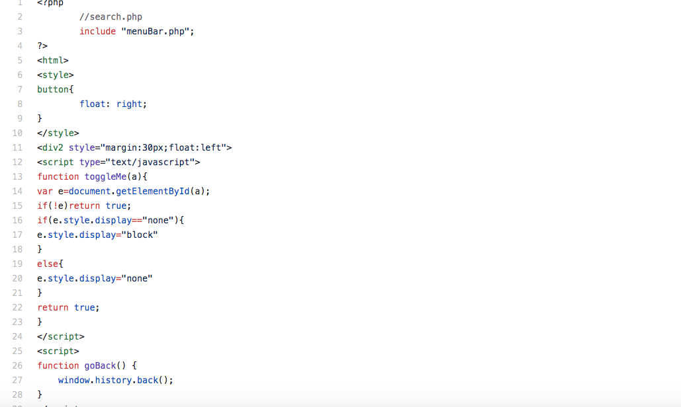

Haotian

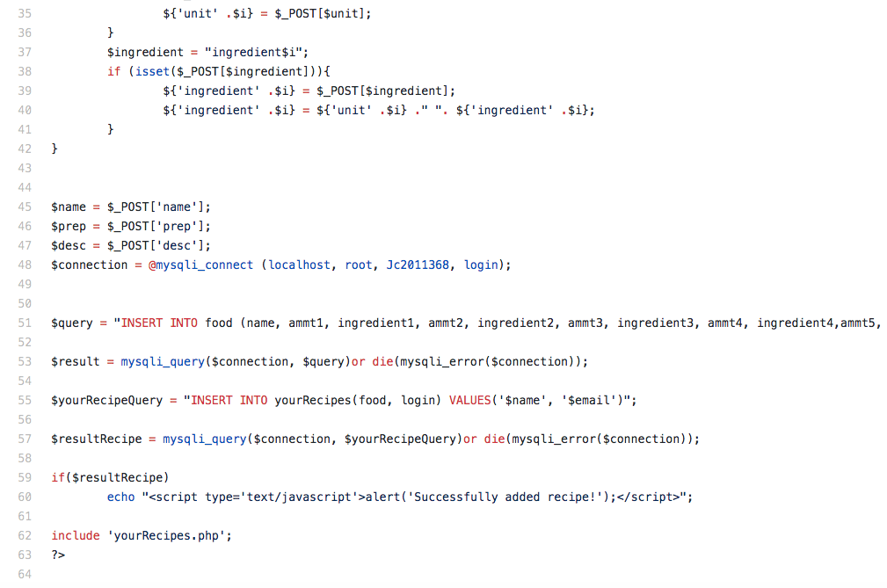

Jacky

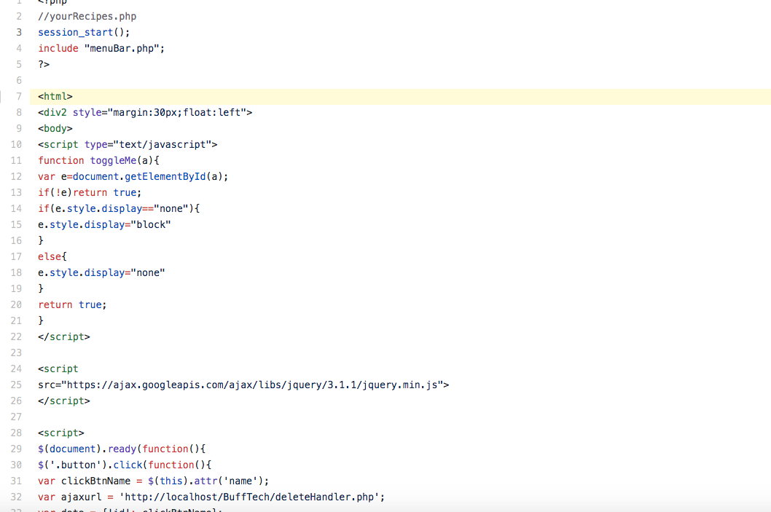

Hua-Pei

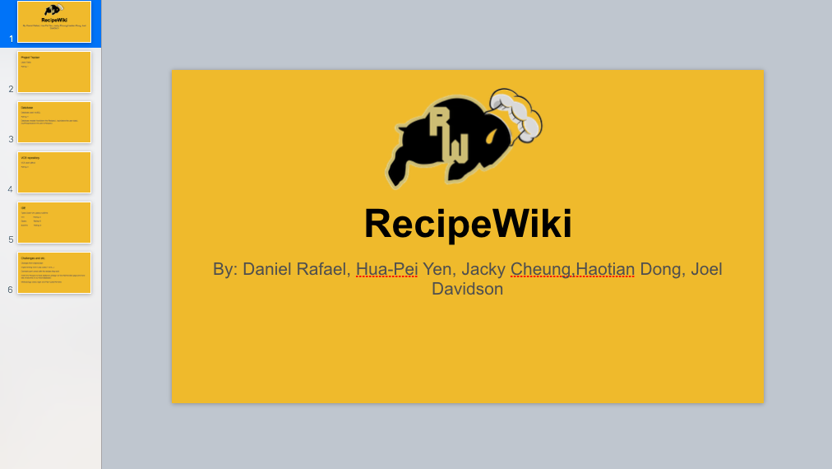

Joel

